**FINAL REPORT**

**STATIC GRADIENT SURVEY**

Well: {{well_name}}

Field: {{field}}

Date: {{date}}



Table of Contents

SURVEY OBJECTIVES 3

BASIC WELL INFORMATION 4

SEQUENCE OF EVENTS 5

STATIC GRADIENT SURVEY RESULTS TABLE 5

STATIC GRADIENT SURVEY RESULT PLOTS 6

OVERALL DOWNHOLE MEMORY GAUGE PLOT 7

DOWN HOLE MEMORY GAUGES OVERALL COMPARISON 8

WELL COMPLETION DIAGRAM 9

WELLHEAD PICTURE­ 10

SLICKLINE MEMORY GAUGES STRING DIAGRAM 11

PCE SCHEMATIC 12

CALIBRATION TOP GAUGE D8699 13

CALIBRATION BOTTOM GAUGE D8698 14

# SURVEY OBJECTIVES

A Pressure Survey was carried out on {{date}} in well {{well_name}} of {{field}} field to perform {{type}} to evaluate the bottom hole pressure and temperature

# BASIC WELL INFORMATION

**GENERAL INFORMATION**

Company : ROO

Field : {{field}}

Well : {{well_name}}

DGS/CPS : {{dgs}}

Test : {{type}}

Rig : RIGLESS

Country/City : IRAQ- BASRA

Depth Reference : GL (Ground Level)

Unit System : Field System

**OPERATION DETAILS:**

Date of test : {{date}}

Co. Representative : ROO-SL Coordinator

NEOS Representative : {{spv}}

**WELL DATA:**

States before test : Producer

Well type : {{welltype}}

Fluid type : {{Fluid}}

Completion type : {{packer}}

Well status : {{welltype}}

Min restriction : {{min-res}}

Casing size : 7”, 29#, L-80

Tubing size : {{tubing}}

Liner size : N/A

Test interval : {{interval}}

# SEQUENCE OF EVENTS

|  |  |  |  |
| --- | --- | --- | --- |
| **End** | **End** | **Time** | **Description** |
| 6:00 | 7:00 | 1:00 | NEOS slickline crew and equipment left from the base to R-043. |
| 7:00 | 8:00 | 1:00 | Got PTW. |
| 8:00 | 8:10 | 0:10 | Gas test was done (O2=20.9, Flammables =0% of LEL, H2S=0 PPM)Permit was signed off to PA. |
| 8:10 | 8:20 | 0:10 | Review JSA and held tool box meeting with slickline crew Risk Assessment discussion JSA. |
| 8:20 | 8:30 | 0:10 | Perform DROPs check list, offload equipment from transport truck and Scaffolding. |
| 8:30 | 9:00 | 0:30 | Started R/U slickline equipment. |
| 9:00 | 9:15 | 0:15 | Remove wireline valve from frame and connect hydraulic hoses.  1. Function test wireline valve rams with hydraulic supply (close 10 sec, open 9 sec). 2. Hydraulic accumulator testing:  a. Accumulator pre-charge pressure: 1500psi  b. Accumulator pressurized to 3000 psi  c. Function testing each rams with accumulator (close 7 sec, open 7 sec, close 8 sec, open 7 sec).  d. Residual accumulator pressure: 2300 psi.  e. Bleed off hydraulic and accumulator pressure. |
| 9:15 | 9:25 | 0:10 | Pressure testing for Quick test sub 2700 psi /10 min. |
| 9:11 | 10:32 | 1:21 | RIH two memory pressure /Temperature gauges Top SN: D8701, Bottom SN: D8700 and Stop at measuring depth 2915 mGL for 20 min. |
| 10:32 | 12:55 | 2:23 | POOH gauges with 8 stations 10 min each (2905,2895,2885,2495,1995,995,495,0 ) mGL as per Client programing |
| 12:55 | 13:30 | 0:35 | Slickline tools at surface, Bleed off LUB, disconnect memory gauges and download the data, inform ROOWSC2 and start R/D. |
| 13:30 | 14:30 | 1:00 | Finished rig down and housekeeping . |
| 14:30 | 15:15 | 0:45 | Pressure test wellhead flange with 250 psi for 5 minutes and 2700 psi for 10 minutes, test Ok. |
| 15:15 | 16:00 | 0:45 | Close PTW. |
| 17:00 | 18:00 | 1:00 | Crew back to base. |

# STATIC GRADIENT SURVEY RESULTS TABLE

**Bottom Gauge D-8699**

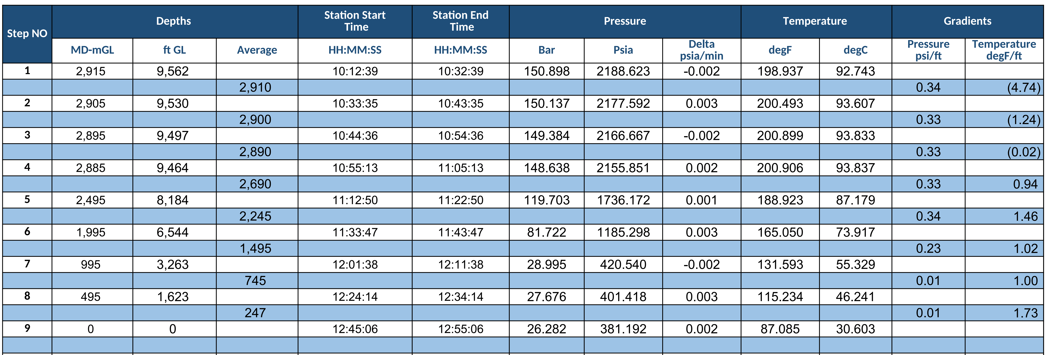

# STATIC GRADIENT SURVEY RESULT PLOTS

**Bottom gauge D-8699**

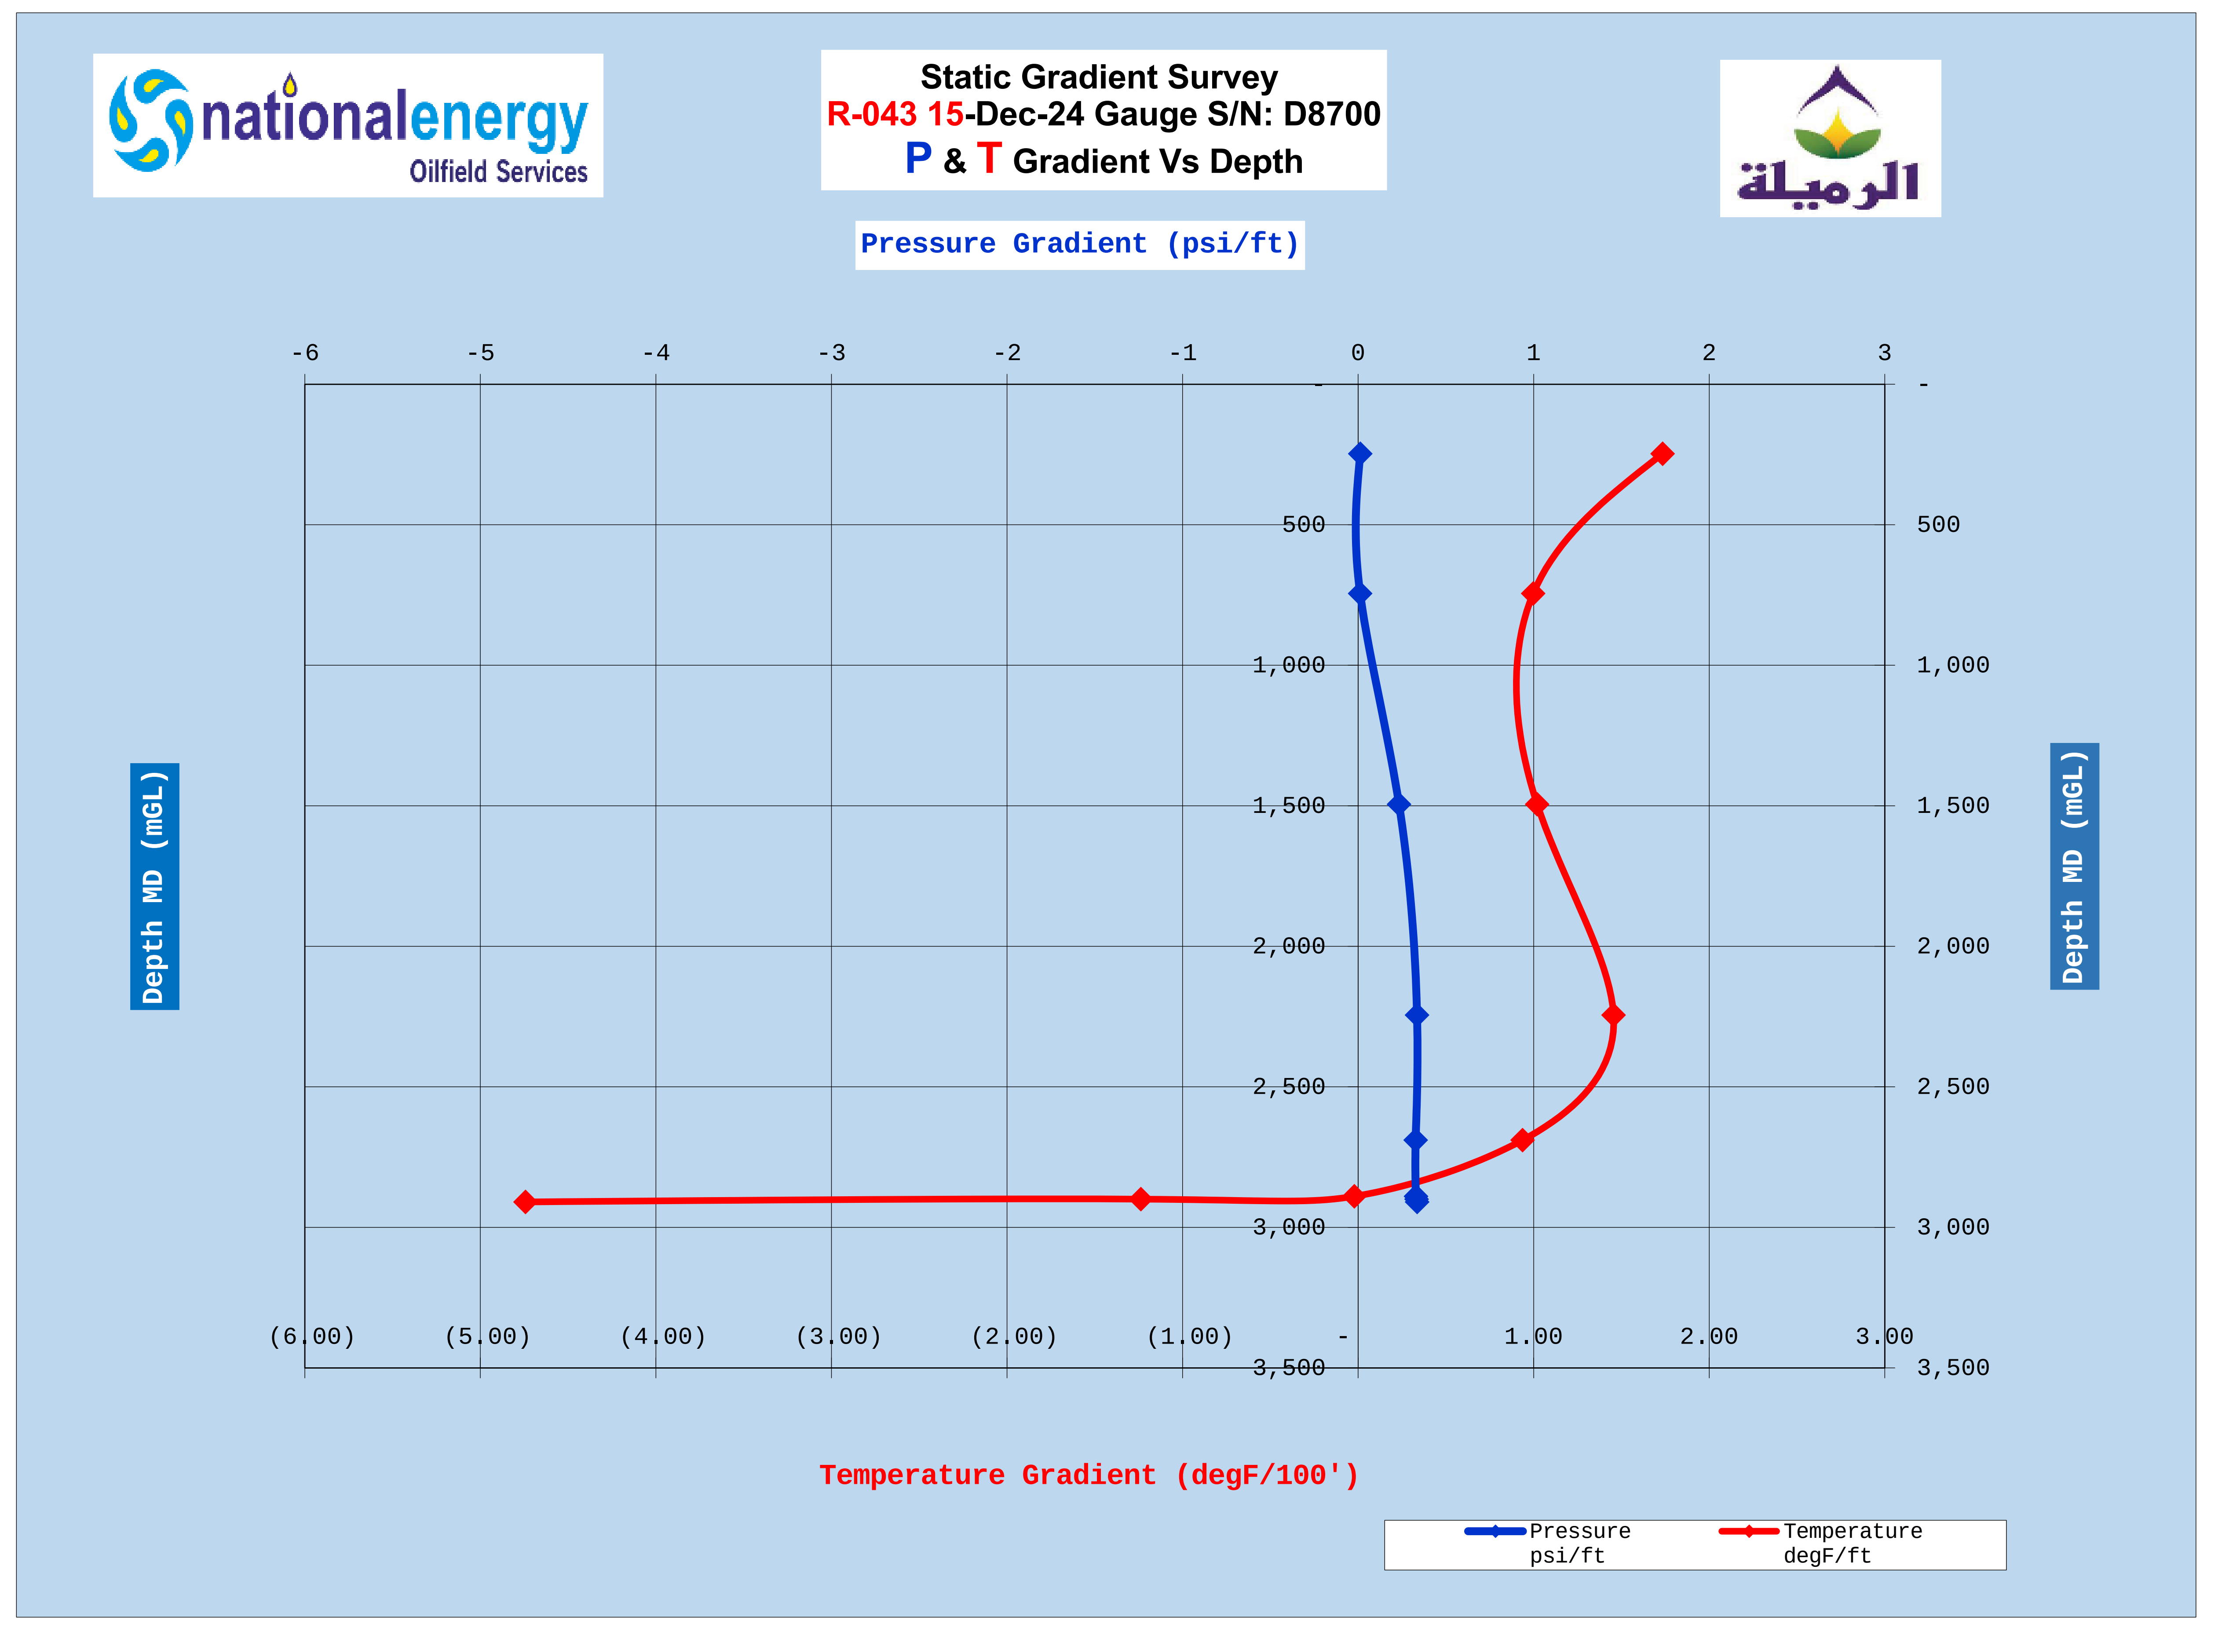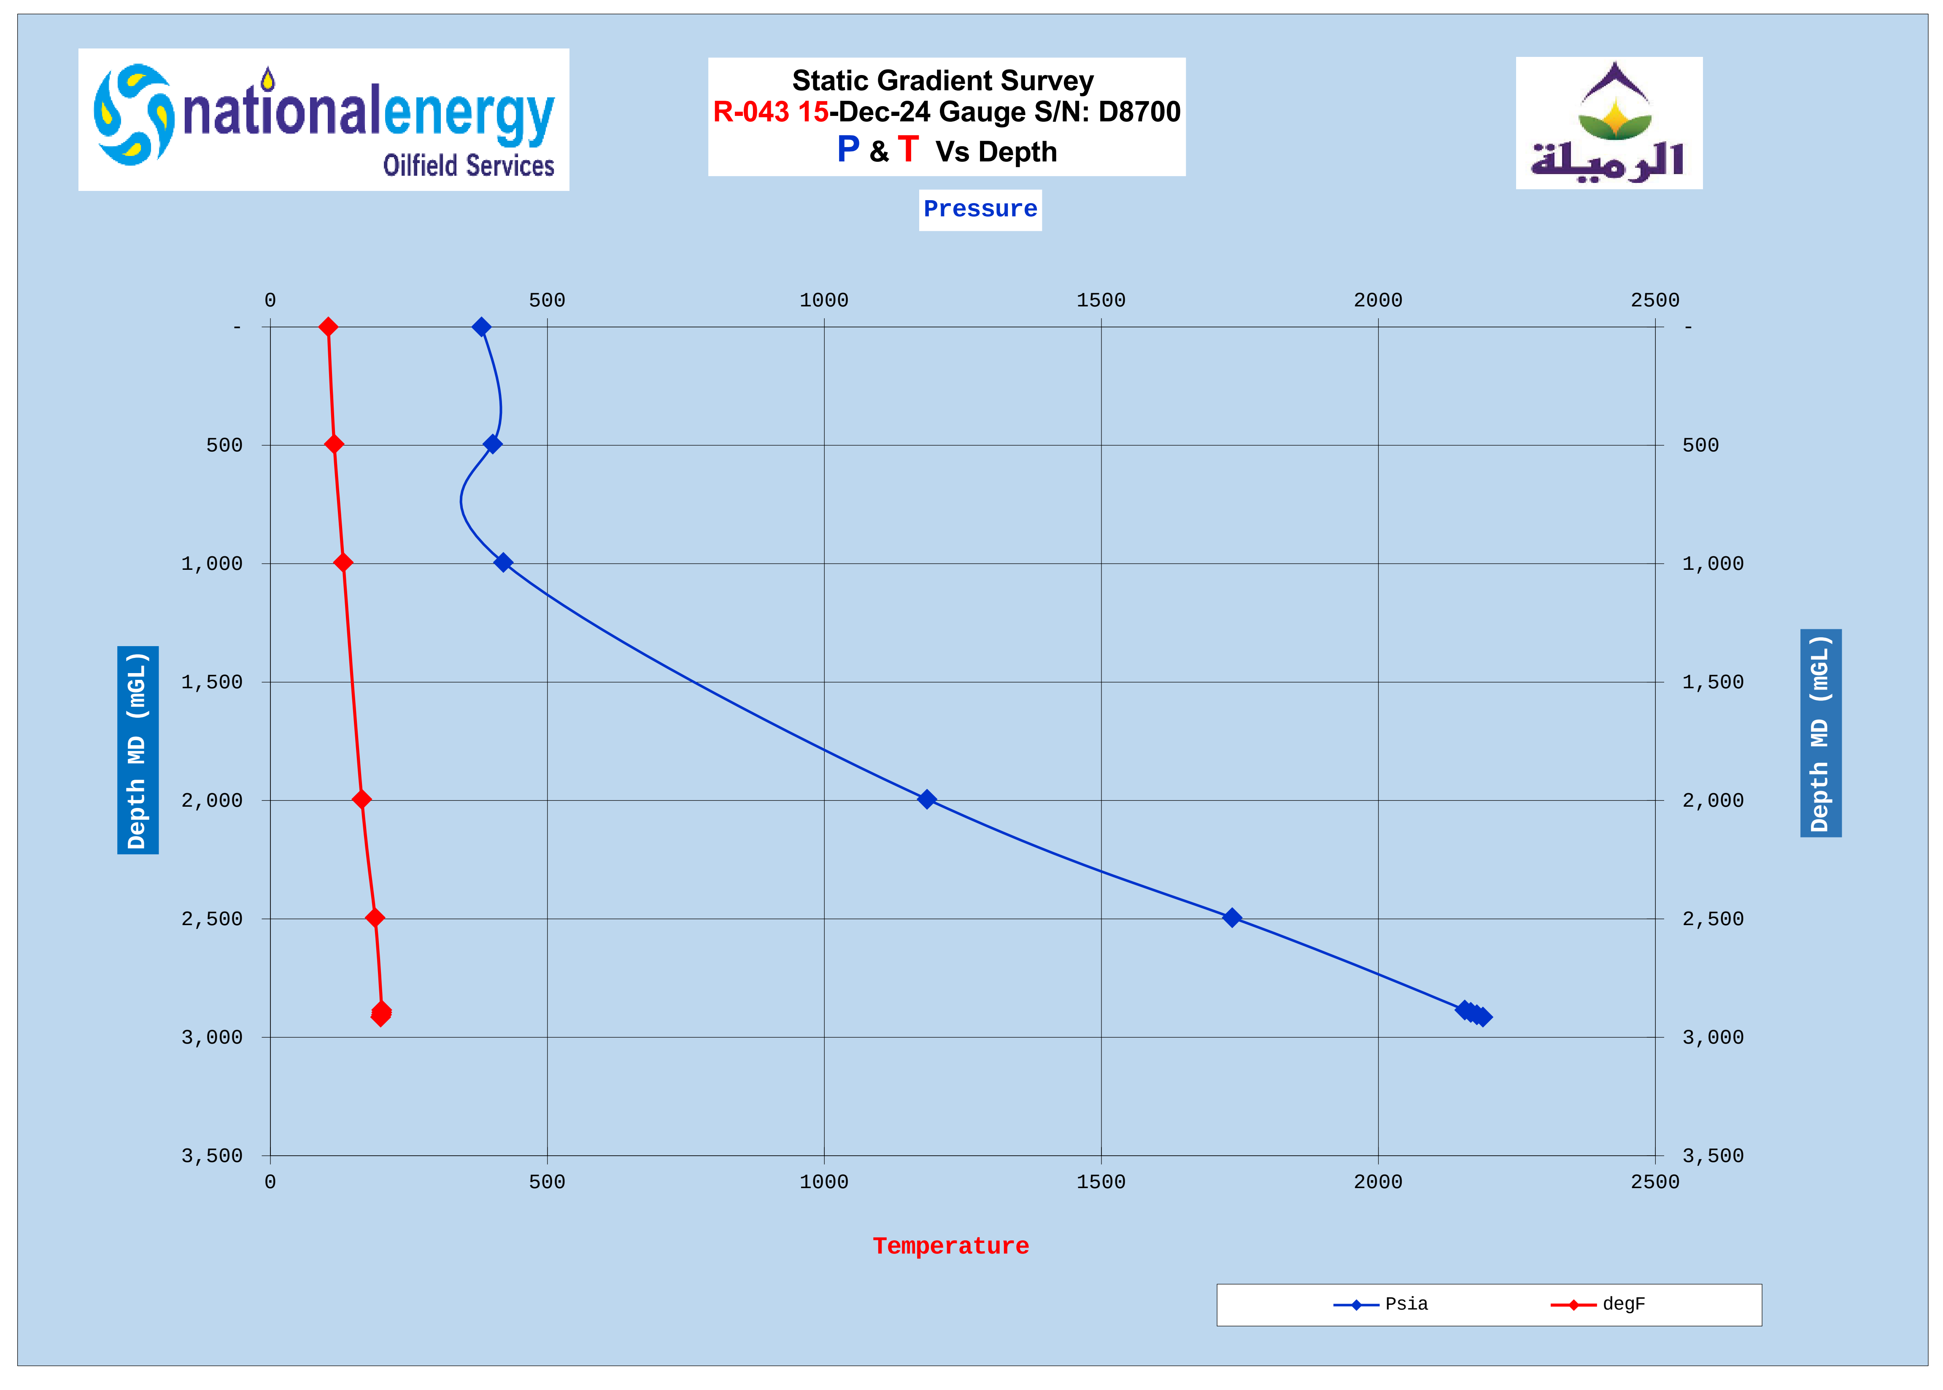

# OVERALL DOWNHOLE MEMORY GAUGE PLOT

**Bottom gauge D-8699**

# DOWN HOLE MEMORY GAUGES OVERALL COMPARISON

**Bottom D8699, Top D8698**

# WELL COMPLETION DIAGRAM



# WELLHEAD PICTURE­

# SLICKLINE MEMORY GAUGES STRING DIAGRAM

# PCE SCHEMATIC

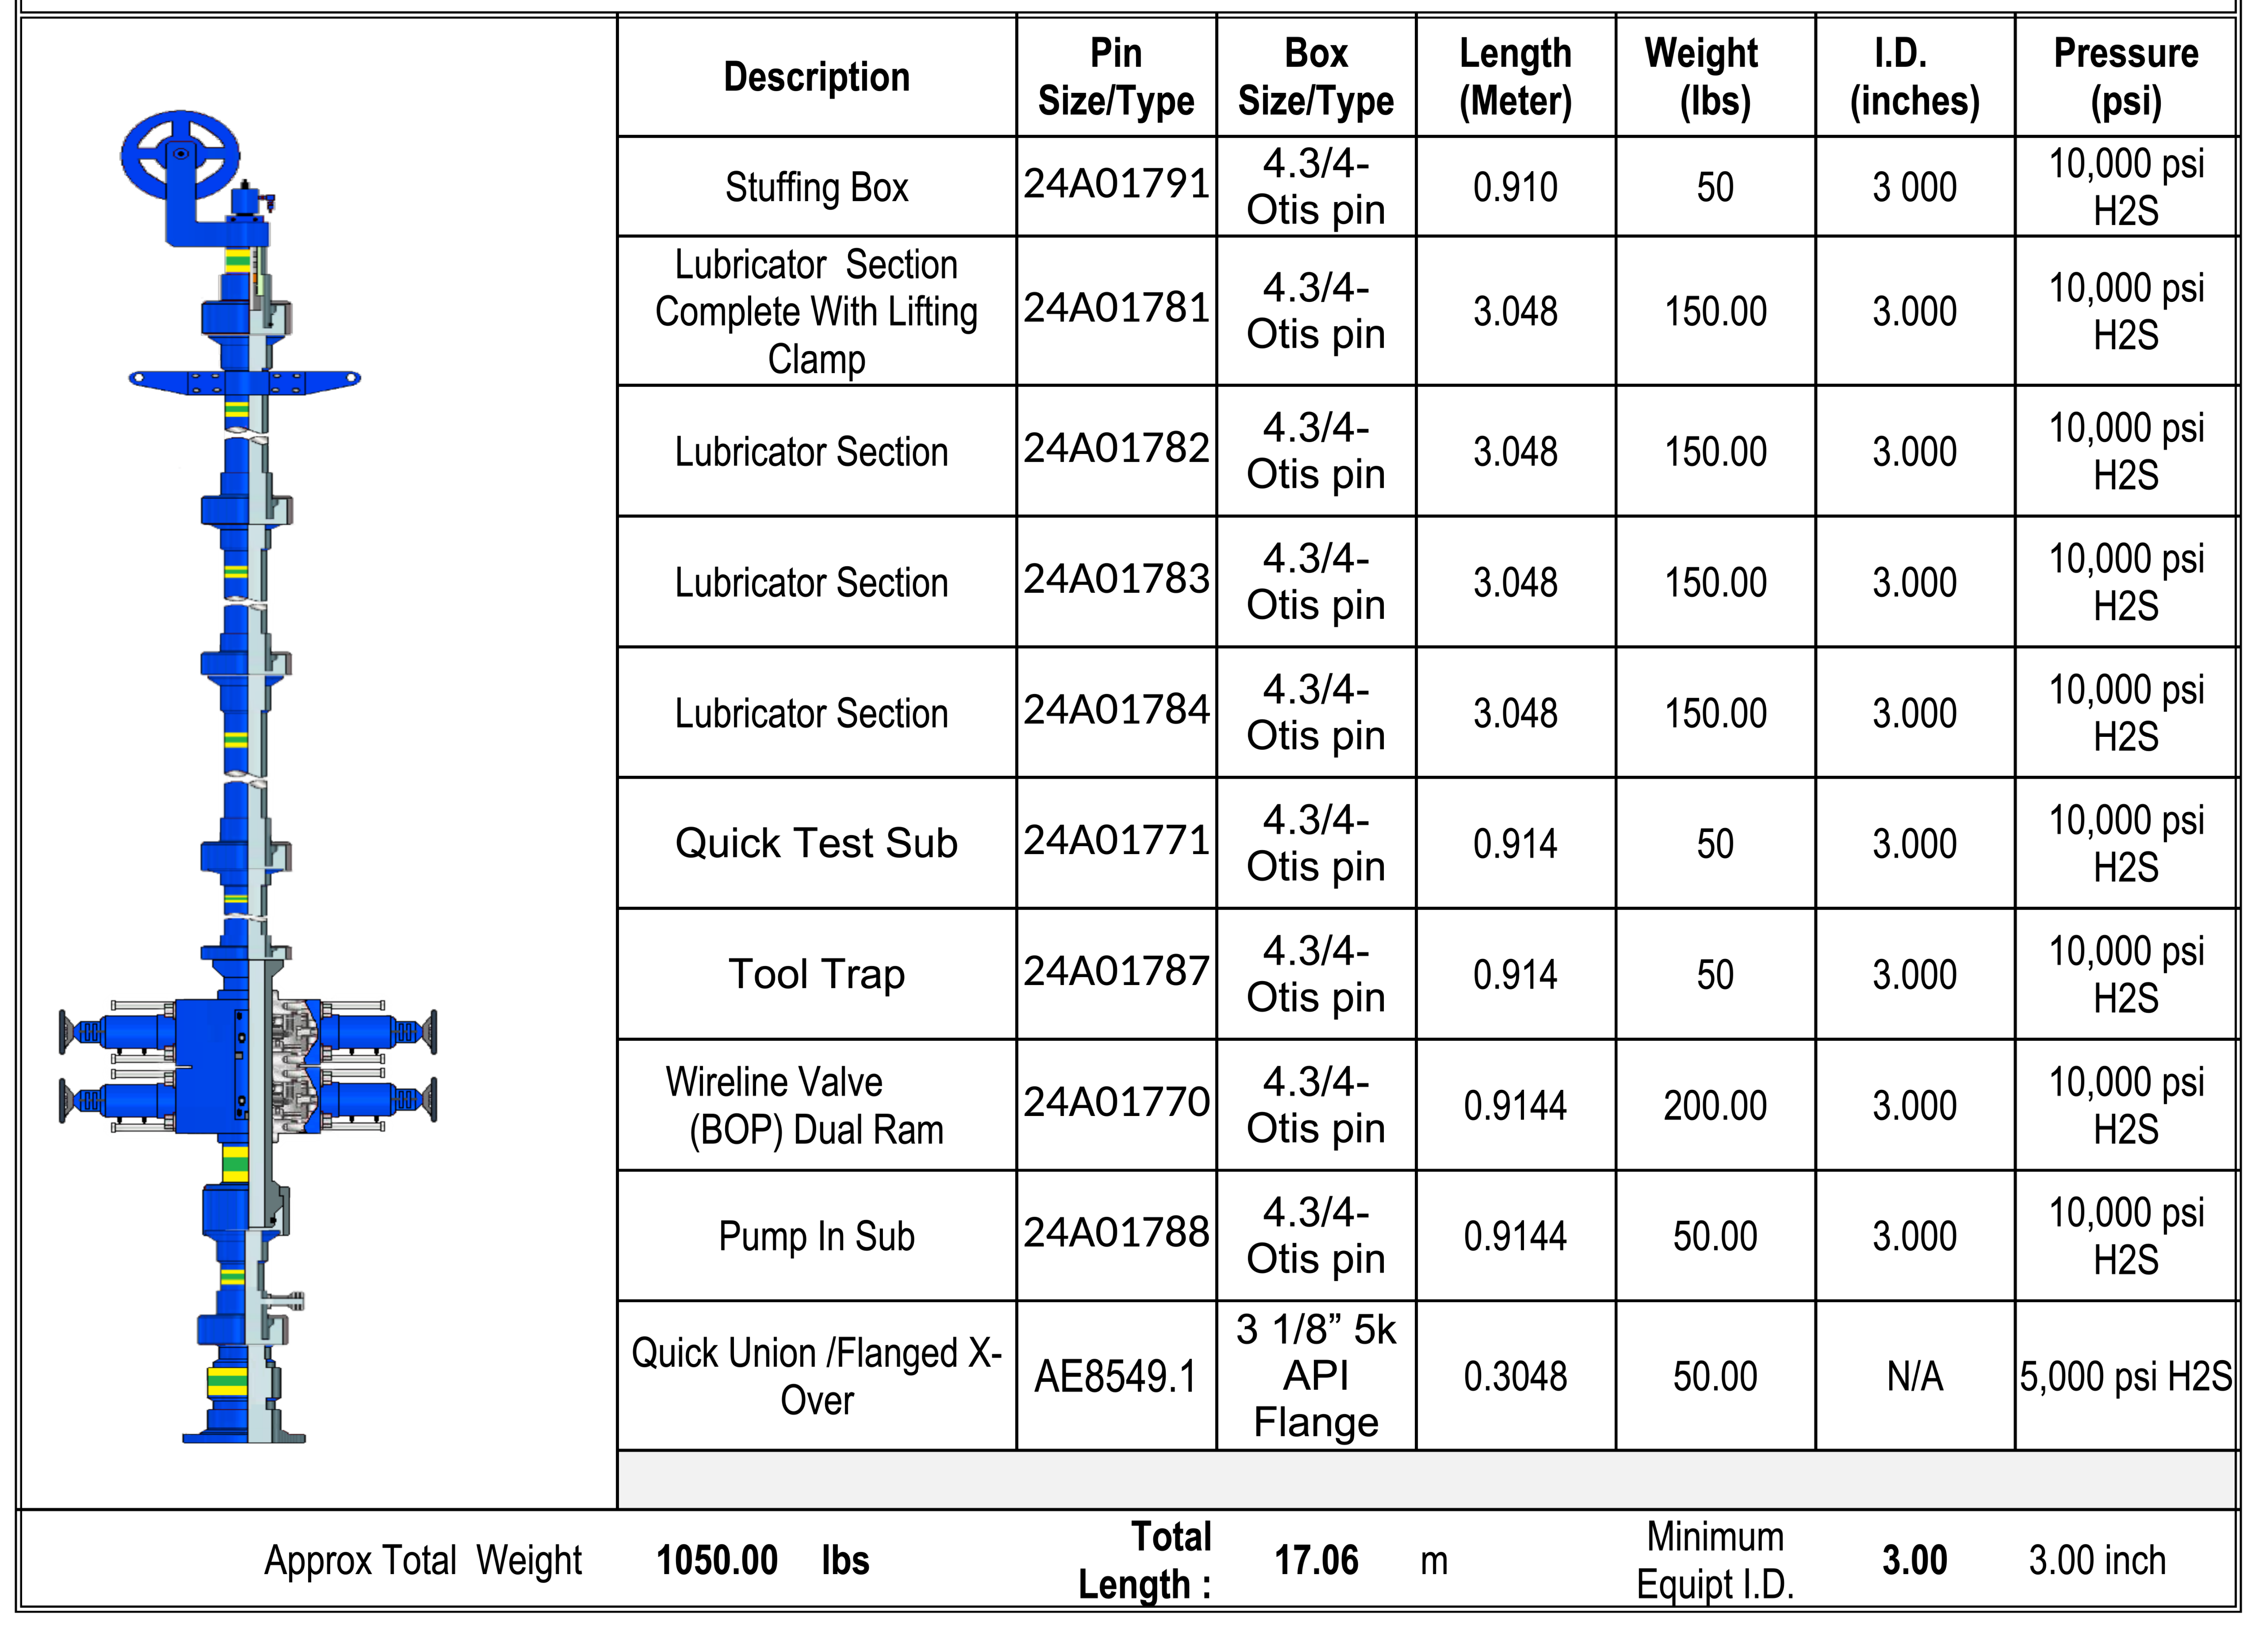

# CALIBRATION TOP GAUGE D8699



# CALIBRATION BOTTOM GAUGE D8698

